Light Comes in Lumps, and Each Lump Carries an Arrow
  - Prologue 1 of Quantum, Actually, Volume 2: A QED Course
Lothar J. Musiol

No equations yet: a detector that clicks, a stopwatch hand that turns while light travels, and one rule — add the arrows, then square

First edition, 2026

How to use this prologue
This prologue needs no algebra beyond squaring a number and Pythagoras' theorem. Read it the way you would read about an experiment in a good popular science book, but with a pencil next to you: every few pages there is a short Try it now box. Do the box before reading on. The answers are at the end of the prologue, after the exercises.
The approach follows the one Richard Feynman chose for his four public lectures, published in 1985 as QED: The Strange Theory of Light and Matter: describe what nature does, with arrows instead of equations, and be honest about what nobody understands. The words and examples here are this course's own. Lesson 1 later turns the same arrows into complex numbers; Prologue 4 builds that bridge gently first. Expect two to three hours.

Learning objectives
- Describe the experiment that shows light arriving in identical lumps (photons).
- Explain why physics can only predict the probability of a click, not which photon will click.
- Draw the arrow for one way an event can happen, using the stopwatch picture.
- Combine several ways by adding arrows tip to tail, and turn the final arrow into a probability by squaring its length.
- Say plainly which parts of this rule are explained and which are simply how nature behaves.

Words you will need
Word | What it means here
photon | One lump of light. A detector either registers a whole photon or nothing.
click | One detection. A photomultiplier tube makes an audible click when wired to a speaker.
probability | A number from 0 (never) to 1 (always); 0.04 means 4 times in 100 on average.
arrow | A drawn arrow with a length and a direction. Physicists call it an amplitude.
final arrow | The arrow you get after adding all the arrows for an event.

1 An experiment you could almost do at home
Take the dimmest light you can make: a small lamp behind several sheets of dark filter. Point it at a photomultiplier, a detector so sensitive that it can respond to the smallest possible amount of light, and connect its output to a loudspeaker.
With bright light the speaker makes a steady roar. Add one more filter and you would expect the roar to become a quieter roar. It does not. It breaks up into separate clicks. Add more filters: the clicks become rarer, but each click is exactly as loud as before. Light, when you look closely enough, arrives in identical lumps. The lumps are called photons.
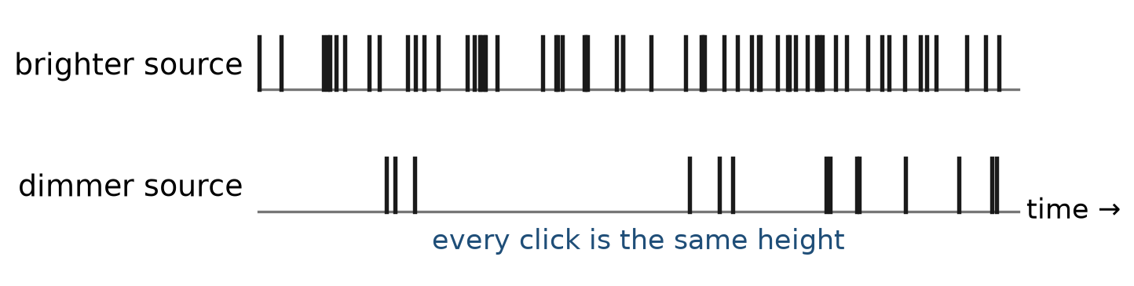
Figure P1.1. The same detector with a brighter and a dimmer source. Dimming the light makes the clicks rarer, never smaller. Each click is one photon.
The photoelectric effect tells the same story with electricity instead of sound. Shine light on a clean metal plate and electrons come off it. Below a certain colour of light — towards the red — no electrons come off, however bright the lamp. Above that colour they come off at once, one electron for each photon absorbed, and brighter light gives more electrons, not faster ones. A wave pouring energy smoothly onto the metal cannot explain this. Lumps of a fixed size can: each photon of visible light carries roughly two electronvolts, and an electron either receives a whole lump or none. Einstein drew this conclusion in 1905.
Try it now 1
A detector records 2000 clicks in a minute. You add a filter that lets one photon in ten through. What do you expect to hear: clicks that are ten times quieter, or about 200 clicks per minute of the same loudness?

2 The theory predicts chances, not events
Now aim the dim light at a sheet of glass, with one detector in front of the glass to catch reflected light and one behind it to catch light that went through. Out of every 100 photons, about 4 arrive at the front detector and about 96 at the back detector. (We are ignoring the second surface of the glass for the moment; Prologue 2 brings it back.)
Which photons are the 4? Nobody can say. Photons from the same lamp are identical, and nothing about one photon tells you in advance whether it will be reflected. This is not a failure of our instruments. As far as anyone has been able to test, nature itself only fixes the odds. Newton already worried about partial reflection three hundred years ago; he never found a satisfactory reason for it, and neither has anyone since. What we have instead is a rule that predicts the odds exactly.
So the job of the theory — of everything in this course, all the way to Lesson 87 — is to calculate probabilities like 0.04. It does that with arrows.
Try it now 2
A probability of 0.04 is predicted for reflection. In a run of 10 000 photons, roughly how many reflections do you expect? If you counted 380 in one run and 415 in the next, would that contradict the prediction?

3 The stopwatch arrow
Here is the rule, built in three small steps.
Step 1: each way gets an arrow. For every way an event can happen — for example, "the photon goes from the lamp to the detector by bouncing off the front of the glass" — you draw one arrow.
Step 2: the direction comes from a stopwatch. Imagine a stopwatch with a single hand that starts when the photon leaves the source and spins steadily for as long as the photon travels. When the photon arrives, you stop the watch. The direction the hand points is the direction of the arrow for that way.
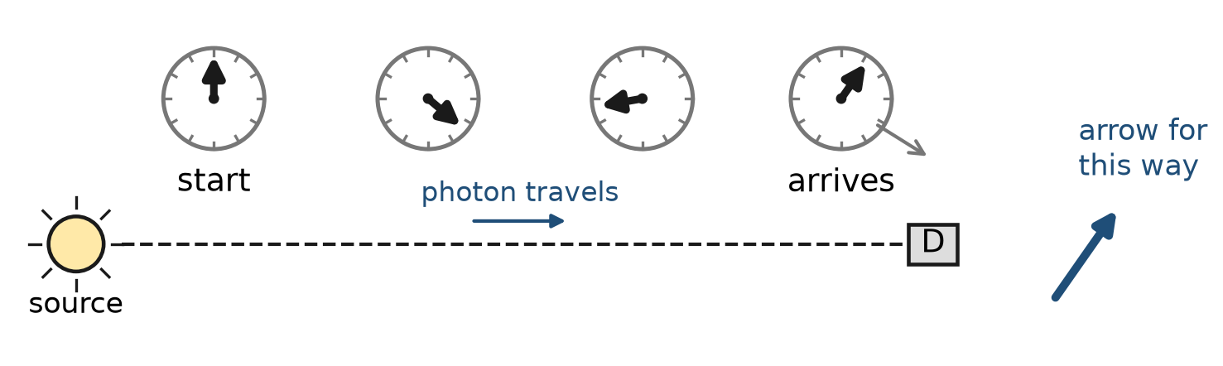
Figure P1.2. The imaginary stopwatch. Its hand turns steadily while the photon travels. When the photon arrives, the hand's direction is copied as the arrow for this way. A longer trip means more turning.
The hand spins very fast. For red light it makes one full turn for each wavelength of travel, roughly two-thirds of a thousandth of a millimetre — about one and a half million turns per metre. Blue light turns faster than red: about two and a quarter million turns per metre. So colour, in this picture, is just how fast the stopwatch spins.
Step 3: the length comes from how likely that way is. For reflection from the front of glass, the arrow has length 0.2. Why 0.2? Because experiment says one surface reflects 4 photons in 100, and 0.2 × 0.2 = 0.04. (Lesson 9 derives the 0.2 from the way light slows down in glass. For now, take it from experiment.)
And then the rule that turns arrows into something you can measure:
The probability is the square of the length of the final arrow.
An arrow of length 0.2 gives 0.2² = 0.04. An arrow of length 0.5 would give 0.25. An arrow of length 1 would give 1: certainty.
Try it now 3
(a) An arrow has length 0.3. What probability does it stand for? (b) An event has probability 0.09. How long is its final arrow? (c) Why can no final arrow be longer than 1?

4 Add the arrows, then square
Usually an event can happen in more than one way. A photon can reach a detector by bouncing off the front of a glass sheet or by bouncing off the back. Our everyday instinct says: add the chances. Nature says something else.
When an event can happen in several ways that you have no means of telling apart, draw an arrow for each way, add the arrows, and square the length of the final arrow.
Adding arrows means joining them tip to tail. Put the tail of the second arrow on the tip of the first, without turning it. The final arrow runs from the tail of the first to the tip of the last.
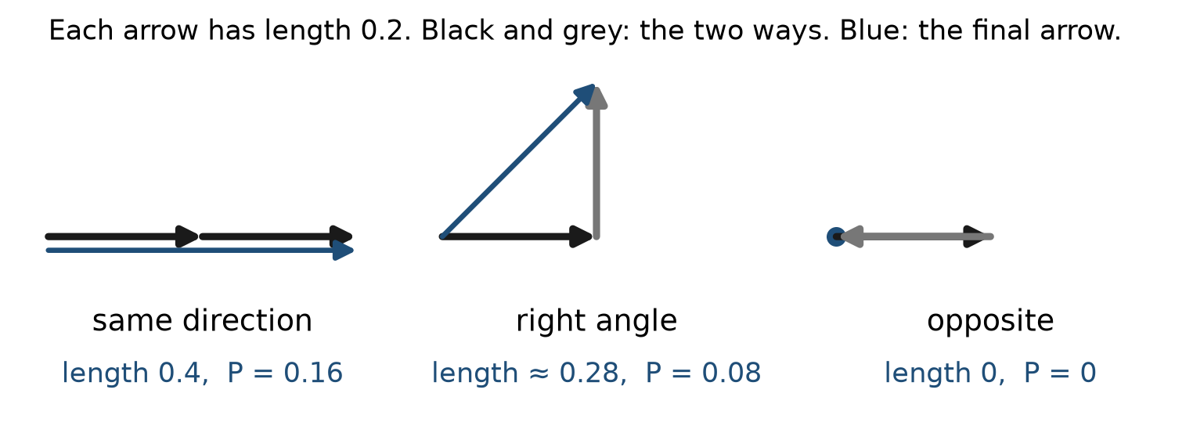
Figure P1.3. Adding two arrows of length 0.2. Same direction: final length 0.4, probability 0.16. At right angles: final length about 0.28, probability 0.08. Opposite: final length 0, probability 0.
Look at what this does. Two ways that would each have a probability of 0.04 on their own can together give 0.16 — four times one of them, not twice. Or they can give 0. Or anything in between, depending only on the angle between the arrows. When arrows reinforce each other, physicists say the ways interfere constructively; when they cancel, destructively. This one rule is behind every interference pattern in optics, and behind every calculation in this course.
Worked example 1
Two ways each have an arrow of length 0.2, at right angles to each other. What is the probability?
Put the arrows tip to tail. They form two sides of a right-angled triangle; the final arrow is the hypotenuse. By Pythagoras, its length squared is 0.2² + 0.2² = 0.04 + 0.04 = 0.08. So the probability is 0.08.
At right angles, and only at right angles, the arrows' squares simply add. That is why ordinary "add the chances" thinking often looks right: when many arrows point in effectively random directions, the result on average is the same as adding the probabilities. The surprises come when the angles are not random.
Worked example 2
Arrows of length 0.3 and 0.1 point in the same direction. Then the second is reversed. Compare the two probabilities.
Same direction: final length 0.3 + 0.1 = 0.4, probability 0.16. Reversed: final length 0.3 − 0.1 = 0.2, probability 0.04. Turning one arrow around changed the answer by a factor of four.
Try it now 4
Two arrows of length 0.1 each. What are the largest and smallest possible probabilities? What is the probability when they are at right angles?

5 When not to add arrows
There is one condition in the rule, and it matters: the ways must be impossible to tell apart. If you put a detector on one route that tells you which way the photon went, the situation changes. Now there are two different final events — "went by way A and was seen there" and "went by way B" — and for different final events you add probabilities, not arrows. The interference disappears.
This is the experimental fact behind every famous two-slit argument. It also explains why the arrow rule never shows up in daily life: large objects constantly leave traces of which way they went, so their arrows never get the chance to cancel.
Try it now 5
A photon can reach a detector by two routes, each with an arrow of length 0.2 and pointing opposite ways. (a) What is the probability if nothing records the route? (b) If a gentle marker records which route was taken without stopping the photon, what is the probability that the detector clicks?

6 What has been explained, and what has not
It is worth being clear about the status of this rule. It has not been derived from anything simpler. It is a description of how nature behaves, discovered because every other description failed. Nobody can tell you why the probability is the square of an arrow, or why the arrows add. What can be said is that the rule has been tested in every situation anyone has thought of, and it has never failed. Feynman's own stance, which this course shares, was that you are not being asked to understand nature in the sense of finding it reasonable, only to see how it behaves.
The rule is also not yet complete. We have arrows for light reflecting from glass because we borrowed the 0.2 from experiment. Prologue 5 shows where such numbers come from: electrons in the glass, and three basic actions out of which everything is built.

Connections to QED
Idea in this prologue | Where it becomes exact
Light comes in photons | Lesson 9 (photon counting) and Lesson 38 (the quantized electromagnetic field)
Arrow = amplitude | Prologue 4 and Lesson 1: an arrow is a complex number
Stopwatch turning | The phase factor e^{−iωt} of Lessons 1, 10 and 12
Add arrows, then square | Superposition and P = |amplitude|² (Lessons 10–11), and every cross section from Lesson 54 on
Distinguishable ways add probabilities | Spin sums and averages from Lesson 54 on

Summary
- Light is detected in identical lumps, photons; dimmer light means fewer clicks, not smaller ones.
- Physics predicts only the probability of a click.
- Each way an event can happen gets an arrow. Its direction comes from a stopwatch that turns while the photon travels; its length comes from how likely that way is.
- For ways that cannot be told apart: add the arrows tip to tail, then square the length of the final arrow. For ways that can be told apart, add the probabilities.

Exercises
Each exercise is labelled Core (needed to follow the next prologue), Extension (deepens the idea) or Challenge (stretches it).
No | Problem
1 | Core. Convert these arrow lengths to probabilities: 0.1, 0.2, 0.5, 0.7, 1.
2 | Core. Convert these probabilities to arrow lengths: 0.01, 0.04, 0.36, 0.5.
3 | Core. Two arrows of length 0.2 point the same way. A third arrow of length 0.2 points the opposite way. What is the final probability?
4 | Core. A dim source sends 50 photons per second at a glass surface that reflects with probability 0.04. How many reflected clicks do you expect in one minute?
5 | Core. Arrows of length 0.3 and 0.4 are at right angles. Find the final length and the probability.
6 | Extension. Red light makes about 1.5 million stopwatch turns per metre of travel. How many turns does the hand make while the light crosses 3 mm of air? Why does the exact number of whole turns not matter for the arrow's direction?
7 | Extension. Two ways have arrows of length 0.2 and 0.1. Find the largest and smallest possible probabilities and explain in one sentence why neither equals 0.04 + 0.01 = 0.05.
8 | Extension. Four arrows of length 0.1 point north, east, south and west. What is the probability? What does this suggest about many arrows pointing in all directions?
9 | Challenge. Many arrows of length 0.1 each point in random directions. Explain, using the right-angle result of Worked example 1, why the average probability is about (number of arrows) × 0.01, as if the probabilities simply added.
10 | Challenge. Explain why a which-way marker on one route destroys interference, even if it does not slow or deflect the photon at all.

Solutions
Try each exercise on paper before you look. If you are stuck, re-read the section named in the exercise, try again, and only then read the solution below.
1. Square each length: 0.01, 0.04, 0.25, 0.49, 1.
2. Take square roots: 0.1, 0.2, 0.6, and about 0.71 (because 0.71² ≈ 0.50).
3. The two aligned arrows make 0.4; the opposite arrow takes away 0.2, leaving 0.2. Probability 0.2² = 0.04.
4. In one minute 50 × 60 = 3000 photons arrive; 0.04 × 3000 = 120 reflected clicks, give or take the natural scatter of about ±11.
5. Pythagoras: final length √(0.09 + 0.16) = √0.25 = 0.5. Probability 0.25.
6. 3 mm is 0.003 m, so about 1.5 × 10⁶ × 0.003 = 4500 turns. Only the leftover part of a turn changes the direction; a whole number of turns brings the hand back where it started. That is why tiny differences in path length matter so much: a change of a fraction of a wavelength changes the leftover angle.
7. Largest: aligned, length 0.3, probability 0.09. Smallest: opposite, length 0.1, probability 0.01. Probabilities of ways that cannot be told apart do not add; arrows do, and the result depends on the angle.
8. North and south cancel, east and west cancel: final length 0, probability 0. Many arrows spread evenly over all directions tend to cancel each other.
9. Add the arrows one at a time. A random new arrow is just as likely to point partly along the arrow you already have as partly against it. The gain and the loss balance on average, so on average the squares simply add, exactly as they do at right angles. Each new arrow therefore adds about 0.1² = 0.01 to the probability. For N arrows the average is about N × 0.01 — the same as adding probabilities. Random angles wash out interference.
10. The marker makes the two routes distinguishable: the final situations "photon at detector, marker says A" and "photon at detector, marker says B" are different events. The rule adds arrows only for ways that end in the same final situation, so with the marker you add probabilities, and the cancelling disappears. It is the information, not a push, that matters.

Answers to Try it now
1. About 200 clicks per minute, each as loud as before. A filter removes photons; it cannot make a photon smaller.
2. About 0.04 × 10 000 = 400. Counts of 380 and 415 are normal scatter (roughly ±20 for 400 expected), so they agree with the prediction.
3. (a) 0.09. (b) 0.3. (c) A probability cannot exceed 1, and the probability is the length squared.
4. Largest: aligned, length 0.2, probability 0.04. Smallest: opposite, length 0, probability 0. At right angles: 0.01 + 0.01 = 0.02.
5. (a) The arrows cancel: probability 0. (b) Now the routes are distinguishable, so probabilities add: 0.04 + 0.04 = 0.08.

Next lesson
Prologue 2 puts the arrow rule to work on a puzzle you can see in any shop window: glass reflects about 4 photons in 100, yet a thin sheet of glass can reflect anything from none to 16, depending on its thickness.

